

**CNG 334**

**Assignment 3 Report**

**Name:** Shayan Nadeem

**Student ID:** 2542413

### TASK 1:

**1)**

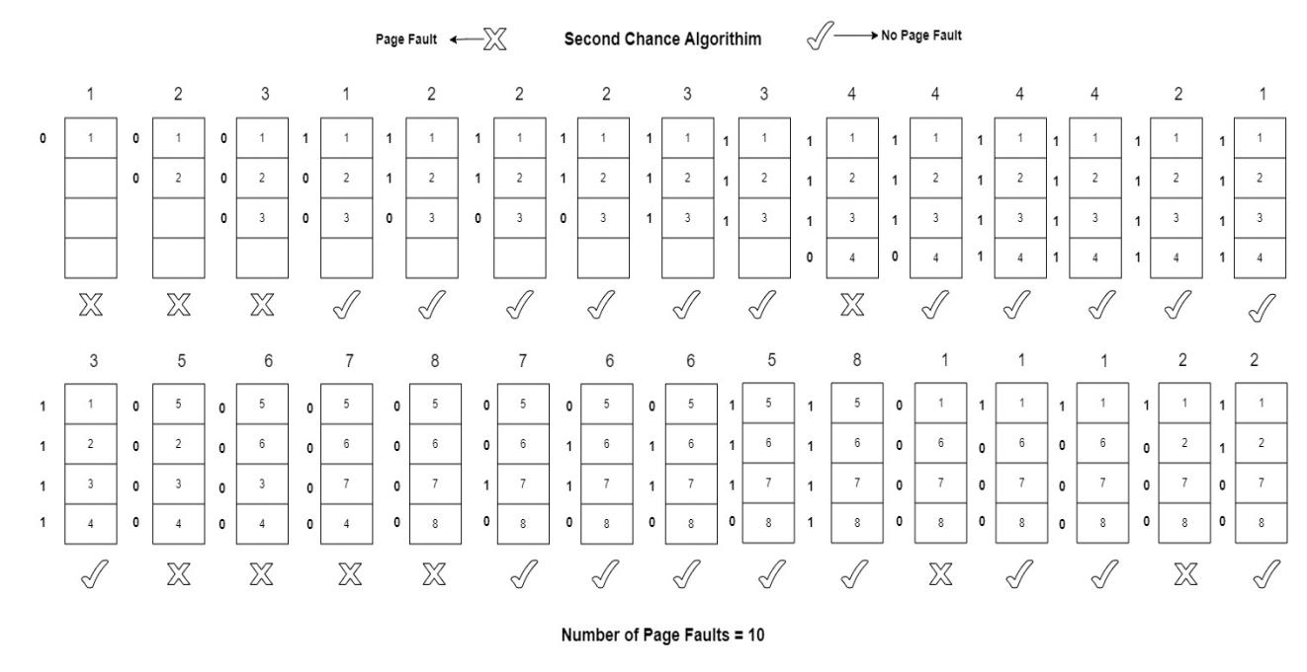

**2)**

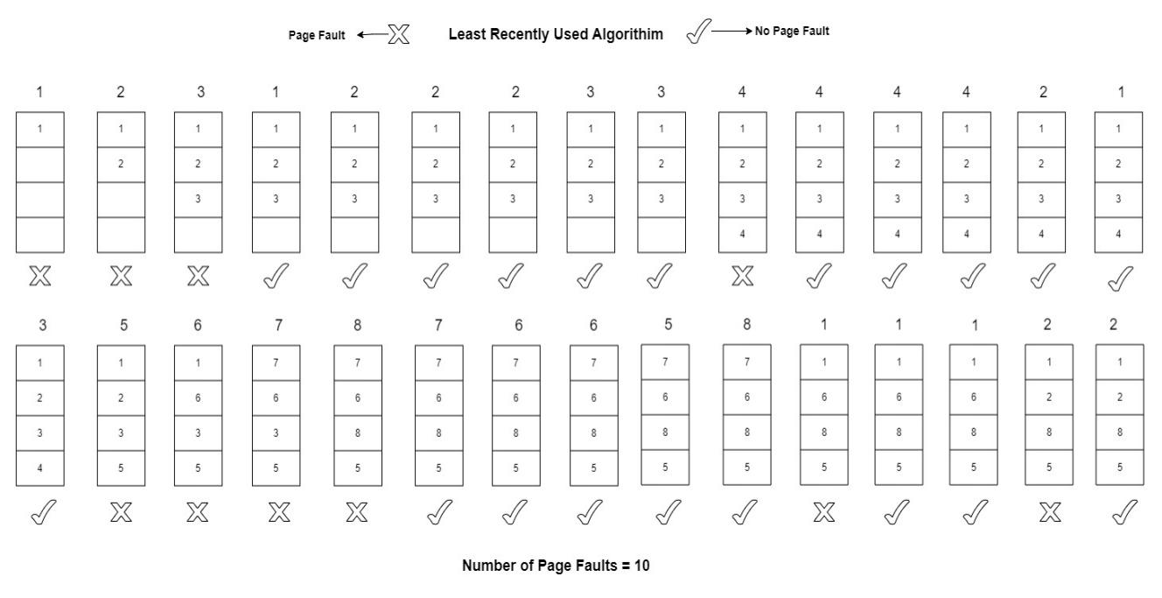

**3)**

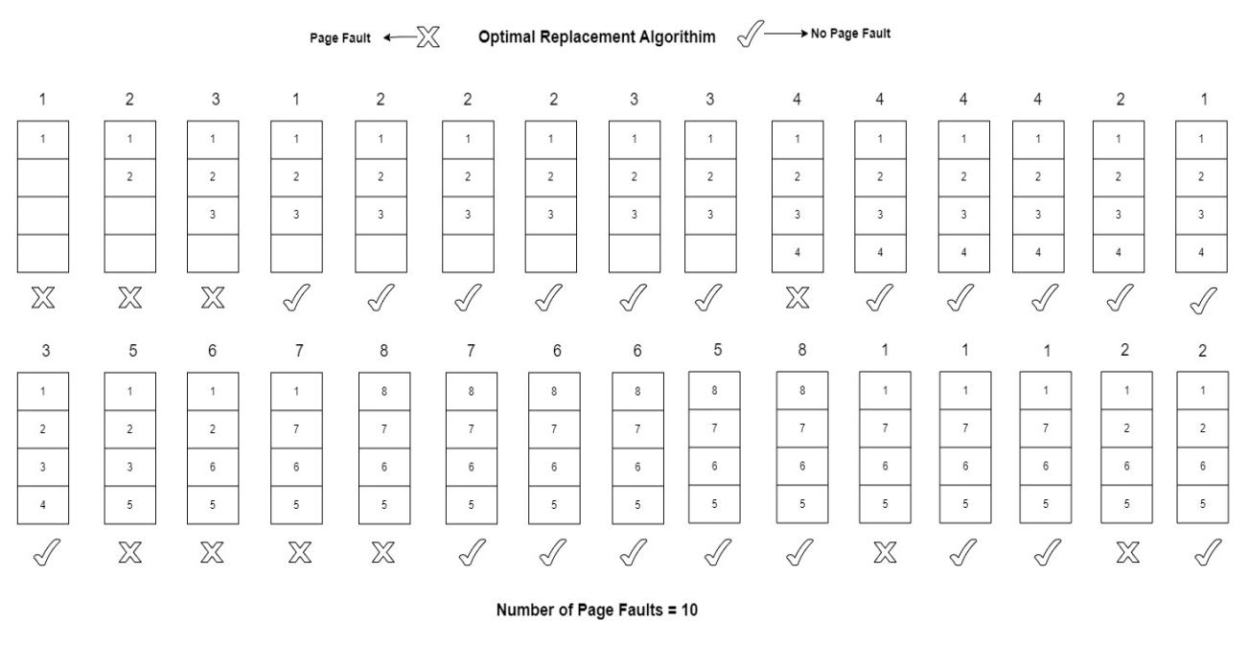

### TASK 2:

**1)**

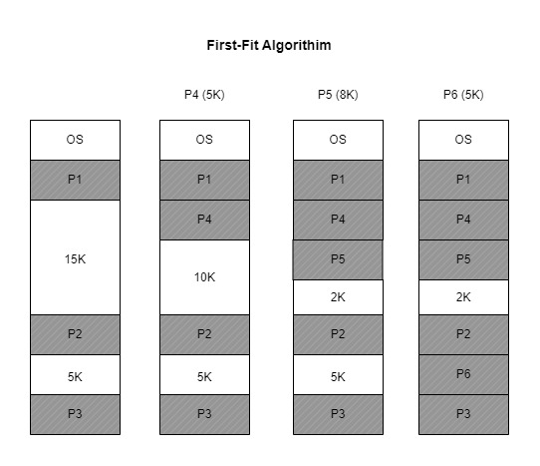

**2)**

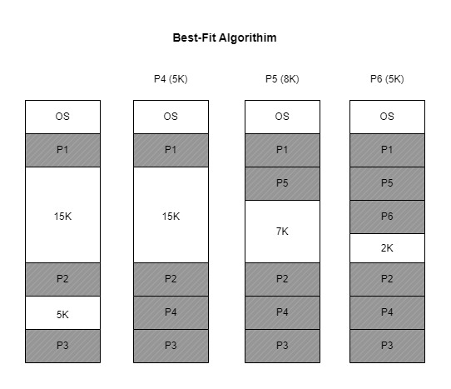

**3)**

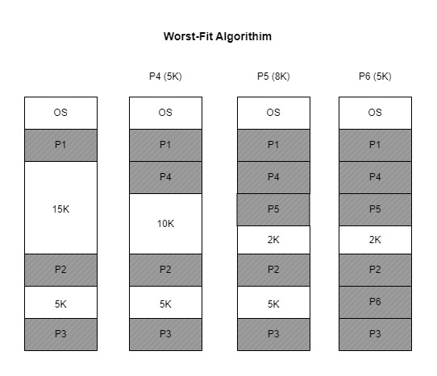

### TASK 3:

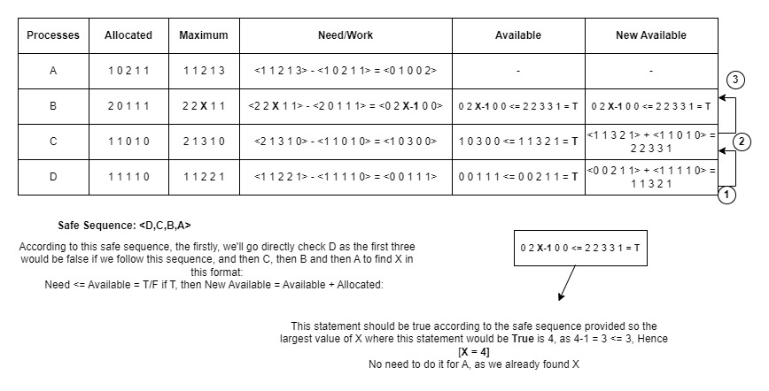

### TASK 4:

1. Swap In/Out Time = (Size/Transfer Rate + Average Latency Time)

Swap Out Time (P1) = (150/60) * 1000 + 10 = 2510 ms

Swap Out Time (P2) = (200/60) * 1000 + 10 = 3343 ms (Rounded)

Swap In Time (P3) = (300/60) * 1000 + 10 = 5010 ms

Total Time = Swap In Time + Swap Out Time = 2510 + 3343 + 5010 = 10863 ms.

**Total Time = 10863/1000 = 10.863 s.**

1. **Logical Address + Base/Relocation Register = Physical Address**

If the Physical Address Value is less than Limit Register Value --> Valid, else Not Valid.

So following these steps:  
  
 1) 990 + 30010 = 31000 = 31000 --> **Valid**

2) 1020 + 30010 = 31030 > 31000 --> **Not Valid**

### TASK 5:

In this solution, we need to use mutex locks to ensure the critical section is preserved for a single customer. Customers will be coming in the shop, and signaling the sleeping barber who will wake up to serve the customers, and when a customer is done with his/her haircut, he/she will signal the barber, this way we’ll ensure that no customer leaves the barber shop without waiting infinitely. This will prevent the any race conditions that might prevail.  
  
(Also it was not clear what sketching a solution means in this context)